
Main Data, s.r.o.
Senická 23, 811 04
Bratislava, Slovak Republic
Tel : +421 7 54789 586
fax : +421 7 54789 585
GSM : +421 905 606 027
e-mail : support@maindata.sk,
Internet : www.maindata.sk

PSI/SI tables generator
Basic version
Version 1.20

Manual
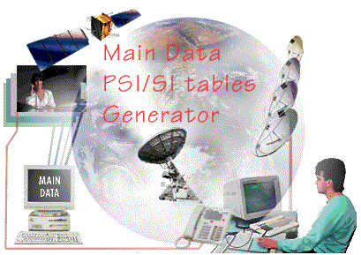

Bratislava September, 2000
© Main Data, s.r.o.
CONTENT

1. Introduction 3
2. Introduction to DVB PSI/SI tables 3
2.1. DVB PSI/SI standards 4
2.2. Abbreviations used in DVB PSI/SI tables 5
3. MD PSI/SI tables generator basic information 6
4. Introduction to MD PSI/SI Generator. 7
4.1. MD PSI/SI tables generator HW requirements. 7
4.2. PSI/SI Generator INSTALLATION. 8
5. Working with PSI/SI Generator 9
5.1. Creating PSI/SI Tables 9
5.2. NIT Wizard 10
5.3. "Add Program" Wizard 11
6. Main MENU of PSI/SI Generator 12
6.1. Output 12
6.1.1. Table frequencies 12
6.1.2. Physical Interface 12
6.1.3. Device Setup 13
6.2. Wizards 14
6.3. Profile 14
6.4. View/Edit 15
6.5. Broadcast 15

Introduction

The scope of this document to provide the administrator/operator of the system with a manual covering both installation and operation DVB PSI/SI Tables generator.

When viewed in electronic form using Microsoft Word in “View: On-line Layout” the reader has access to a Table of Contents frame enabling skips to selected sections directly, allowing simple and fast orientation within this document.

MD PSI/SI Generator can be used at a time at only one PC.

Introduction to DVB PSI/SI tables

In a Digital Television, which deploys MPEG-2 compression algorithm for video and audio, the same bandwidth can transmit several (5-9) TV programming with same quality of video and audio as well as data.

Not only thanks to MPEG compression but also to easy ability to transmit data and standardization how these data should be formatted there are Service Information implemented into Digital Television Broadcast.

It was done in order to make selection of programs for end-user "user friendly" and in order to avoid an end-user to choose programs by codes and numbers on one side and save bandwidth for transmitting full descriptions with program names etc on the other side. PSI/SI tables are packetized into Transport Stream packets as all other streams like video, audio and data.

PSI/SI tables thus provide IRD (Integrated Receiver Device) information about content being broadcast within tuned frequency and optionally information about other transport streams.
Thus PSI/Si tables among other purposes gives IRD the information required to find selected video, audio or data program by the user.

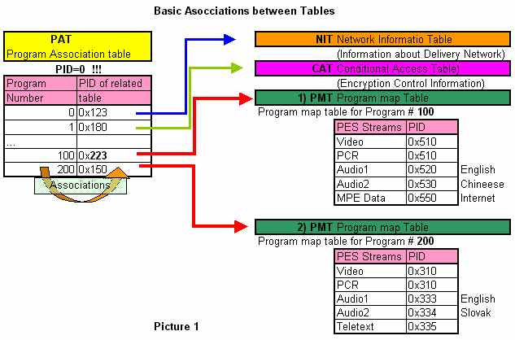
Golden rule in PSI/SI tables is that main "root" table called Program Association Table (PAT) is broadcast at PID = 0. This table is searched by IRDs first. IRD analyses its content by decoding packets bearing PAT table. PAT provides association to other tables PID. Then IRD knows where from it should receive and decode other related tables like PMT, CAT, NIT, SDT etc.
Figure 1

There are several PMT tables - one for each program which can be comprised from several components like Video, Audio, PCR, Teletext and/or data etc.

In case programs are encrypted the PMT also will tell which packets contain data necessary for de-encryption of specific program element (ECMs).
In case service provider uses some encryption algorithm EMM messages (sent inside CAT) give access to programs to a user or a group of users.
SDT tables provides information about service names, the name of service providers and service type (TV, audio, Teletext, Data etc).

In order to IRD navigate among various transport stream, a Network Information Table (NIT) is broadcast. It contains frequency plan of the complete network, for example at which frequencies different transport stream are broadcast, what is symbol rate, Forward Error correction setting and satellite position (in case of satellite) etc.

How the tables should be format is specified in several standards.

DVB PSI/SI standards

[1] MPEG-2 ISO/IEC 13818-1 "Information Technology - Generic Coding of Moving Pictures and
Associated Audio information: Systems
[2] DVB SI ETS 300 468 V.1.3.1. "Digital broadcasting systems for television, sound and data
services; specification for Service Information (SI) in Digital Video Broadcasting (DVB) systems"
[3] DVB SI ETR 211 "Digital broadcasting systems for television, Implementation guidelines for the use
of MPEG-2 systems; Guidelines on implementation and usage of service information"
[4] DVB SI Allocation Draft ETR 162 Digital broadcasting systems
for television, sound and data services; Allocation of Service Information (SI) codes for Digital Video Broadcasting (DVB) systems
–––––––––––––––––––––––––––––––––––––––––––-––––––––––––––––––––––

Other related standards
[5] Languages ISO 639.2
[6] Countries ISO 3166

Basic set of PSI/SI tables is defined by ISO 13818-1 ISO standard for MPEG-2 transport layer system.

MPEG defines PAT, PMT, and CAT tables.
Further DVB group has defined in DVB standard ETSI (later EN) 300 468 V 1.3.1. and ETR 211, Draft ETR 162 additional PSI tables some of them are mandatory NIT, SDT, EIT, TDT and rest of them are optional see Figure 2.

Abbreviations used in DVB PSI/SI tables

BAT Bouquet Association Table
BCD Binary Coded Decimal
bslbf bit string, left bit first
CA Conditional Access
CAT Conditional Access Table
CLUT Colour Look-Up Table
CRC Cyclic Redundancy Check
DIT Discontinuity Information Table
DVB Digital Video Broadcasting
EBU European Broadcasting Union
EIT Event Information Table
EMM Entitlement Management Message
EPG Electronic Program Guide
ETS European Telecommunication Standard
FEC Forward Error Correction
IEC International Electrotechnical Commission
IRD Integrated Receiver Decoder
ISO International Organization for Standardization
LSB Least Significant Bit
MJD Modified Julian Date
MPEG Moving Pictures Expert Group
NIT Network Information Table
NVOD Near Video On Demand
PAT Program Association Table
PID Packet IDentifier
PMT Program Map Table
PSI Program Specific Information
PSTN Public Switched Telephone Network
QAM Quadrature Amplitude Modulation
QPSK Quaternary Phase Shift Keying
rpchof remainder polynomial coefficients, highest order first
RS Reed - Solomon
RST Running Status Table
SDT Service Description Table
SI Service Information
SIT Selection Information Table
SMI Storage Media Interoperability
ST Stuffing Table
TDT Time and Date Table
TOT Time Offset Table
TS Transport Stream
uimsbf unsigned integer most significant bit first
UTC Universal Time, Co-ordinated

MD PSI/SI tables generator basic information

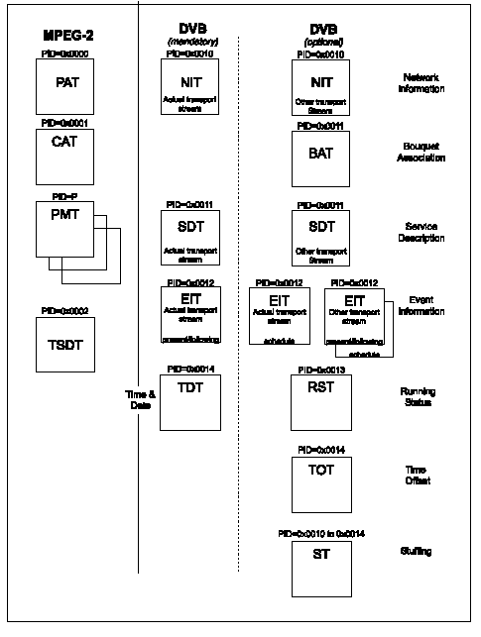
MD PSI GEN tables
FIGURE 2

PSI Gen generates following set of tables PAT, PMT, CAT, NIT and SDT as described in Picture 2. PMT tables are inside PAT tables as a root structure.

Introduction to MD PSI/SI Generator.

MD PSI table generator allows to:
- Edit PSI tables
- Generate PSI/SI tables in frequencies required
- Encapsulate PSI/SI tables into TS packets
- Interface via different physical interfaces DVB-ASI, RS422 or Ethernet with TCP/ip or UDP.

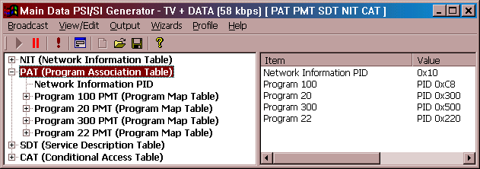
Figure 3

MD PSI/SI tables generator HW requirements.

MD PSI/SI tables generator can be operated at PC under Windows Operating system.
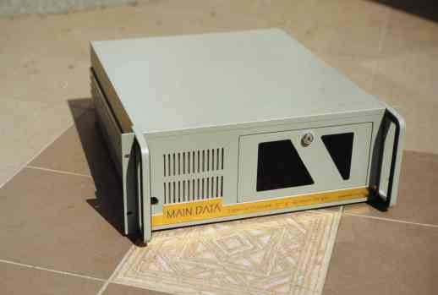
PC must be equipped with either Ethernet or RS422 board or DVB-ASI for interfacing to other DVB equipment.
DVB
Remultiplexor
DVB Multiplexor
DVB-ASI
1. Ethernet TCP or UDP
2. DVB RS422 synch.
3. DVB-ASI
Encryption
MD
PSI/SI Generator
PAT, PMT, NIT, CAT, SDT

Encoder 2
Encoder 1
Encoder ..n
Figure 4
PC must be equipped with HW key, which is provided together with SW package as a license. HW key must be connected to the parallel port of PC.
PC in normal configuration is connected to DVB Remultiplexor as described in Figure 4.

PSI/SI Generator INSTALLATION.

In order to install PSI/SI generator run setup.exe from a Disk_1 what will initiate installation process.

After a first screen appears, installation process will start.

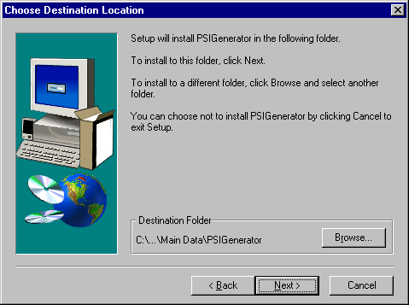

Working with PSI/SI Generator

Creating PSI/SI Tables

Complete set of PSI/SI tables is formed by set of standardized Tables like PAT, CAT, PMT further NIT, SDT (and others like EIT, NIT other, BAT, SDT other, RST, TOT) see figure 2 above.

Each table consist from several descriptors. Descriptors consist from single or multiple values.
MD PSI/SI Generator user interface copies root structure of these tables. In order to assist operator with more complex actions like adding New Program or NIT which impact various tables and various descriptors, there are Wizards incorporated for some selected actions.

On the left side there is complete set of tables and descriptors as an offer for operator. By double click at some tables Wizard is initiated. By double click at descriptors - descriptor is added into the PSI/SI tables with default values. Default values can be further changed by double click on them in the right side of a working area see figure 5.
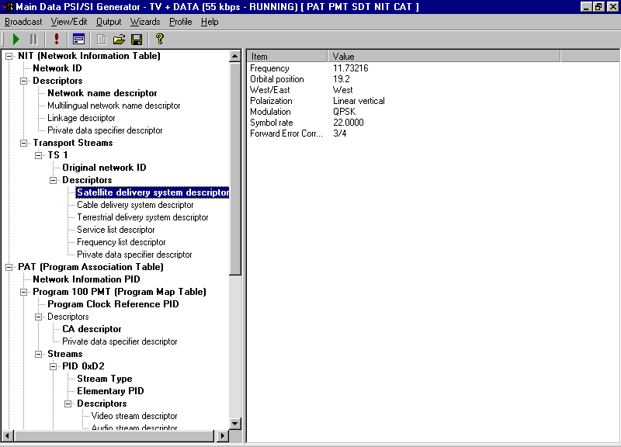
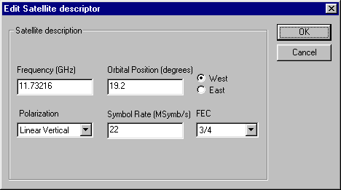
"TV + Data" = Name of Profile
[55 kbps] = Total Speed
RUNNING or STOPPED status
PAT, PMT ... = PSI Tables
generated
"Offer " side
area
1.Double click at descriptor
adds him to right side with default values
Selected descriptor
area
2.Double click at VALUE
allows to EDIT its value
Figure 5
Descriptors can be deleted by DEL when selected in left "offer" side.

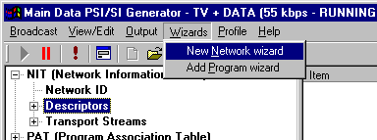
NIT Wizard
Figure 6

When you first run PSI/SI Generator NIT Wizard is initiated.

NIT Wizard can be also called from a menu.

1st Screen see Figures 7 & 8
of NIT Wizard allows you to choose DVB Standardized Network ID (values from 0x0001 to 0xFF00). In case your network does not have yet DVB allocated Network ID you can use private Network IDs dedicated for private use (from interval 0xFF00 to 0xFFFF). Network name can be typed into its field.
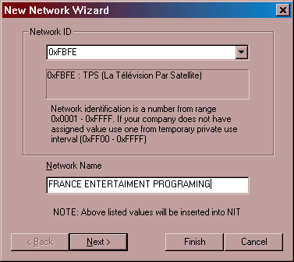
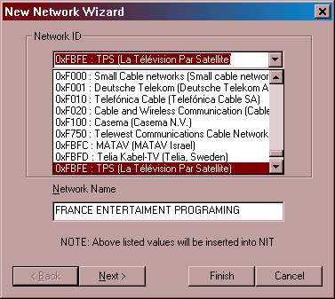
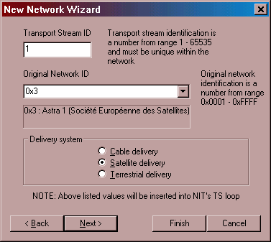
Figure 8
Figure 7
Figure 9
2nd Screen see Figure 9
Transport Stream ID - manually type in.
Original Network ID - select from a list.

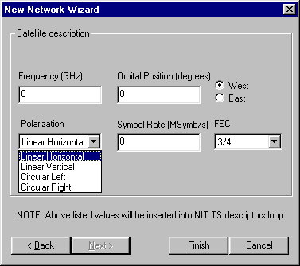
Figure 10

3rd Screen see Figure 10
Frequency is defined in [GHz] e.g. 12.544
Orbital position - manually (max 180 º)
Polarization - select from the list
Symbol rate is defined in [Msymbol/s] - manually
FEC - select rate from the list

"Add Program" Wizard
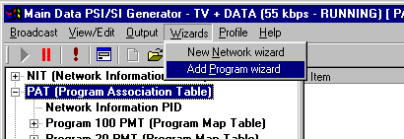
Figure 11
Add program Wizard can be called either from
- Menu Wizard > Add program or by
- Double click at PAT table at left side. See Figure 11.

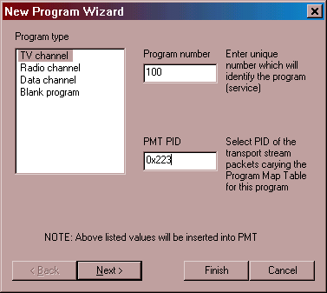
1st Screen See Figure 12
Figure 12
Allows to specify Program type, its number and PID of PMT in PAT table.

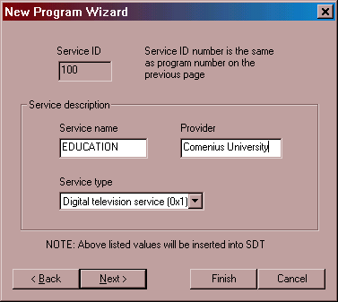
Figure 13
2nd Screen See Figure 13
Allows to specify Service name, Provider and Service type which are part of SDT table.

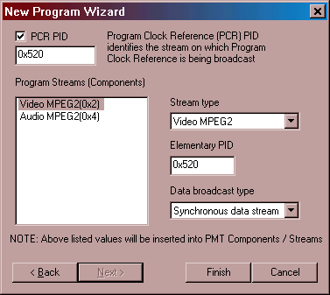
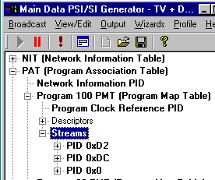
Figure 14

3rd Screen See Figure 14
Allows to specify PIDs for Video and Audio Stream/Component.
When you need to add any additional Stream into this PMT go to its PMT > Streams and double click on streams.

Main MENU of PSI/SI Generator

Output

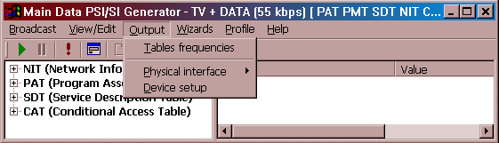
Has 3 submenus all related to output.
Figure 15

Table frequencies

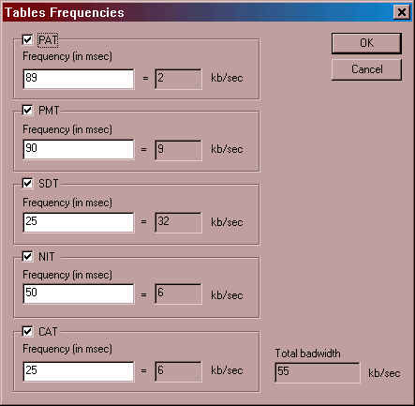
Provides interface for:
Figure 16
- Setting frequency
- Enable/Disable Broadcast of specific PSI/SI tables in checkbox

Total bandwidth indicates how much bandwidth is required to transmit selected PSI/SI tables with given Frequencies.

Physical Interface
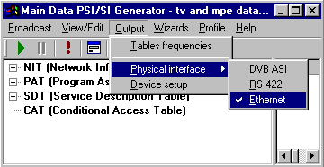
Figure 17
Submenu Is dedicated for selecting output Physical interfaces.
Chosen one can be in second step configured in "Device Setup".

Device Setup
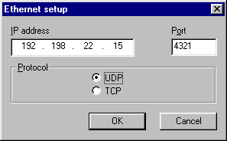
Figure 19
There are 3 different configuration dialog boxes depends on Physical Interface chosen.

a) For example Ethernet output Device Setup allows you to specify protocol, IP address and Port. See Figure 19.

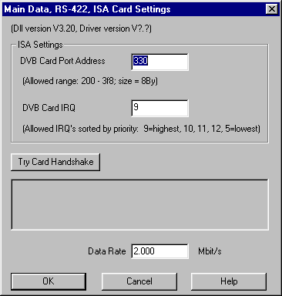
b) RS422 synchronous ISA board configuration should be configured by setting Port Address and DVB Card IRQ.
Figure 20
It is recommended to try communication with the card by Handshake.
See figure 20.

- DVB-ASI

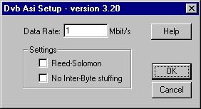
DVB-ASI board setup is simple as shown in Figure 21.
Figure 21

It can generate either 188 bytes long TS packets or 204 bytes long TS packets with RS FEC.

Stuffing can be either interpacket or interbyte.
Interbyte stuffing inserts filling packets among each bytes.

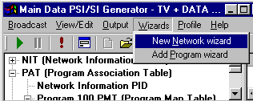
Wizards
Figure 22

New Network Wizard is described in detail
in chapter 5.2. and
Add Program Wizard is described in detail in chapter 5.3.

Profile
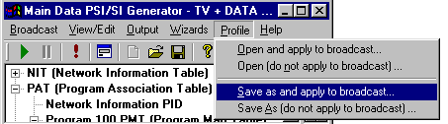
Figure 23

Profiles represent a set of PSI/SI tables. For easier manipulation with PSI/SI tables you can store different sets of PSI/SI tables for later use.
When you have stored PSI tables in specific directory let say C:\PSI\profiles you can choose and open.
In case you wish to broadcast this set of tables you will choose menu "Open and apply to broadcast..". In this case in title bar previous name of profile will be changed to this new selection.
In case you want to open profile but do not want to apply to broadcast you have to choose "Open (do not apply to broadcast)... In this case old set of tables will continue to be broadcast while you can edit open set of PSI tables and save it or apply to broadcast later on.

Similar logic is implemented in case of saving. In this case you may want to apply new set of PSI tables into broadcast or only save it for later use. So similarly option
"Save as and apply to broadcast ..". will change the name of actually transmitted profile while
"Save as (do not apply to broadcast)..". will not change name of profile but will keep previous profile to be transmitted.

Profiles are stored as simple files with *.psi filenames.

View/Edit

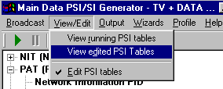
Because there is several different sets of PSI tables this menu gives you access to either running set of PSI tables for reviewing, or allows you to view Edited PSI tables (in this option unused descriptors are not displayed) or Edit PSI tables (in this case full set of available descriptors appears on left side).
Figure 24
In Edit mode unused descriptors are normal and used one are bold.

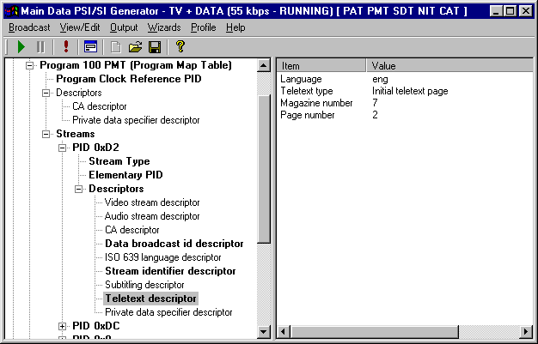
Unused "offered" descriptor s are not bold. There are no values displayed on the right windows for unused decriptors.
Double click will add it into PSI/SI tables with default values which can be edited.

Used descriptors are bold.
On the right side field and its values are displayed (e.g. Teletext)
Double click at fields allows editing values.
Figure 25

Broadcast
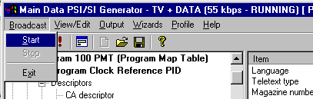
Figure 26
Is very trivial. It allows you Start, Stop MD PSI/SI generator or completely exit PSI/SI generator.

The current status RUNNING or STOPPED is showed in title bar.

Main Data, s.r.o.
Senická 23, 811 04 Bratislava, Slovak Republic
tel : +421 7 54789 586
fax : +421 7 54789 585
GSM : +421 905 606 027
e-mail : support@maindata.sk, Internet : www.maindata.sk

